* **Worship Services and Lectionary**

**Friday, April 8th, 2022**

**Malayalam Holy Communion Service** at 10:00 AM

Theme: Fortieth Friday – Christ who transcends Temptations

1st Lesson: Jeremiah 7:3-17

2nd Lesson: 1 Peter 1:13-22

Epistle: Romans 8:35-39

Gospel: Luke 4:1-13

* Senior Fellowship & Healing Hearts Ministry members will assist the Service

**Sunday, April 10th, 2022**

**English Holy Communion Service** at 8:30 AM

Theme: Hosanna – Lord Save Us

1st Lesson: Zechariah 9:9-17

2nd Lesson: Romans 11:16-36

Epistle: Colossians 1:14-23

Gospel: Mark 11:1-18

* Missouri City and Stafford area members will assist the Service
* **Lenten Prayer Meetings**
  + Monday, April 4, **at 7:00 PM**, on Zoom
  + Tuesday, April 5, **at 7:00 PM**, on Zoom
  + Wednesday, April 6, **at 7:00 PM**, on Zoom
  + Thursday, April 7th, **at 7:00 PM**, on Zoom

[https://us02web.zoom.us/j/4403 20308?pwd=NmhBVnVhcnRKOUkxUE9h SGRyYXFsUT09](https://gmail.us1.list-manage.com/track/click?u=d0b2b58ec212bde400340b2c0&id=70a25fbe27&e=2829c1ce79)  
Meeting ID: 440 320 308  
Passcode: 2222  
One tap mobile  
+13462487799,,440320308# US (Houston)



* **Organizational Announcements**
* **Sunday School**

1. We'll have Sunday School today, Sunday April 3rd at 10:30 am with a singing session at Sunday school hall. Only students, teachers and head start parents are allowed in the Sunday school hall for singing sessions.

2. Next Sunday April 10th we'll start the Sunday school with a singing session immediately after the church service.

3. Palm Sunday Sunday April 10th. There will be a Palm Sunday procession to church before the service starts at 8:15 am. Please meet at Sunday School Hall for the procession. Request all students to wear all white on this Sunday and come early to participate in the procession.

4. Good Friday Service - Good Friday service starts at 9am on Friday, April 15th. All students and teachers are encouraged to participate in Good Friday service at church. The services will be in both English and Malayalam.

5. Diocesan Exam: Diocese Sunday School Exam is scheduled for May 15, 2022.

- The Diocese exam syllabus includes 20 lessons from the curriculum book and 5 lessons from the Mar Thoma Foundation and Vision book.

- If you have any additional questions or concerns, please reach out to the SS Leadership Team.

6. Intramural competition:

a. Singing Competition - April 24th immediately after service at church. Please see the singing competition guidelines as attached.

b. Story Telling competition - Sunday May 1st in class.

c. Elocution - Sunday May 22nd

d. Bible Quiz - To be announced later, but please see the topics for bible quiz in the competition guidelines.

e. Memory verse competition - Memory verse competition can be done at any time in May in class. Please check with your teachers for the dates.

7. Final Exam - Sunday May 29th.

8. Summer session - June 5th through August 7th.

9. VBS - July 21 through 23rd

10. Regional Intramural competition - July 30th.

Sincerely,

John Varghese (Anil) &

Sunday School Leadership Team

* **Youth Fellowship**

We’re going bowling! Join us on Saturday, April 9th at 12:30 PM. Keep a lookout on our social media pages or the YF GroupMe for more information.

Thank you,

Thomas Benjamin

YF Joint Secretary

* **Young Family Fellowship**
  + This Thursday, April 7th, we are starting a new series on the “Genius of Generosity” at 8:30 PM.
  + Please join us as we start this quarter studying the theology of money.
  + A Zoom link will be sent later.

Varghese Mathai

YFF Secretary

* **Yuvajana Sakhyam**
  + Yuvajana Sakhyam is organizing a fund-raising lucky draw coupon as part of the Southwest Regional Badminton doubles tournament to be held on April 2 and 3. The coupon costs $50. First place winner receives an Apple IPAD Pro, second place winner receives a 65in Samsung 4K TV, third place winner receives an Apple watch.
  + A portion of the proceeds will be contributed to Charity.
  + Drawing will be held later today.
  + Support Teams competing in the Badminton Doubles tournament semi-finals and finals today.
    - Dallas K Boys vs. TMC Strikers
    - Team IMTC vs. Smash Brothers Oklahoma
  + Also, savor delicious Indian food at the bake sale.

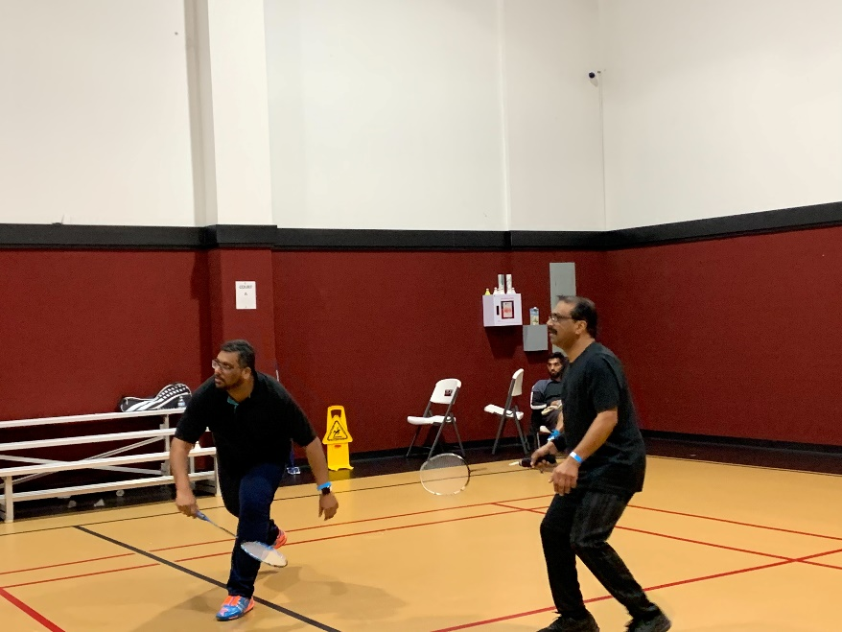

Thanks,

Viju Varghese

Yuvajana Sakhyam Secretary - Cell :(832)785-5442

* **Condolences**
* **Mr. P. K. Kuriakose** (87), the father of Mrs. Leena Eappen of the Galveston and Other area prayer group, received the heavenly call on Saturday, March 26th at Kothamangalam. The funeral and viewing were conducted on Tuesday, March 29th and the body was donated to the Government Medical College, Kalamassery.
* Mrs. Marriamma Thomas (76), the elder sister of Mrs. Aleyamma Varghese (Rosamma) of the Alief Sugar Land prayer group, received the heavenly on Thursday, March 31st at Prakkanam, Pathanamthitta. The funeral was held on Friday, April 1st at the Prakkanam Orthodox Church.
* May God comfort all family members with His Divine Peace.
* Please uphold both families in your prayers.
* **Colonia Mar Thoma Church – Vacation Bible School**

VBS will be held June 17-18 (Friday & Saturday)

We need Volunteers & Drivers for VBS and other events. Both youth and senior members are requested to help. Contact Shawn Varghese for more details.

* **Kessesa Ordination – Dn. Jason Varghese**

The Holy Qurbana and Holy Ordination for Dn. Jason Varghese will be celebrated by Rt. Rev. Dr. Isaac Mar Philoxenos Episcopa on Saturday, April 30th, at 7:30 AM at Immanuel Mar Thoma Church, Houston. Please attend with prayers to bless this solemn occasion.

* **Mar Thoma Messenger**

Mar Thoma Messenger - official publication of our Diocese.

It is published from New York every three months. Please sign up and become a subscriber of Messenger. You can sign up for Three Years for $35.

For more information, please contact: Mrs. Jooley Zachariah or Mr. Shawn Varghese.

* **St. Thomas Mar Thoma Church – Tetelestai**

The St. Thomas Mar Thoma Church Choir and Sunday School are presenting the story of the passion week. Please attend this presentation on Saturday, April 9th at 5:30 PM, at the St. Thomas Mar Thoma Church located in Cypress, Texas.

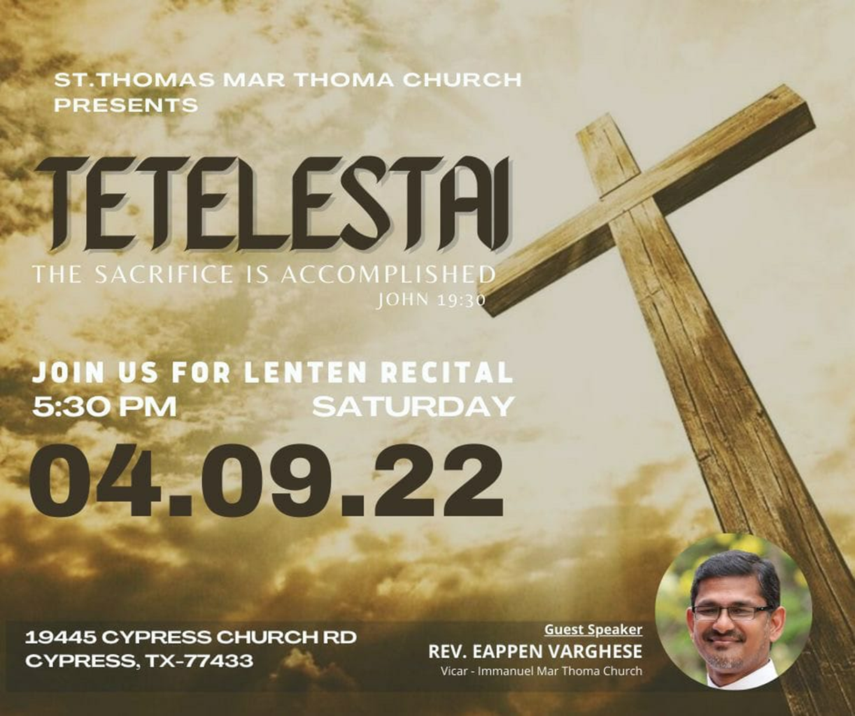

* **Offertory**

**Sunday, March 27th:** $3,867

General: $1,937, Birthday: $1,630 & Wedding: $300

Diocesan Sunday Collection goal: $7,460

We are approximately $2,000 short. Please help.

Join us for tea and snacks in the Fellowship Hall.

We need sponsors for snacks.

Have a blessed new week!

Reji George

**TMC Secretary**

Phone: 713-806-6751

Email: [Reji.George@yahoo.com](mailto:Reji.George@yahoo.com)

Email: [secretary@trinitymtc.org](mailto:secretary@trinitymtc.org)